**DATASET:**

**Q) Find payment type wise gender count of the customer)**

**CODE:**

DEFINE paygender() RETURNS C{

log=load '/user/training/Pallavi/cust' using PigStorage(',') AS (id:int,name:chararray,age:int,gender:chararray,city:chararray,pay:chararray);

gr=group log by (pay,gender);

$C=foreach gr generate group,COUNT(log.$3);

};

**TERMINAL:**

pig -f /home/training/Desktop/paygender.pig

pig

import '/home/training/Desktop/paygender.pig';

Aa =paygender();

Dump aa;

**OUTPUT:**

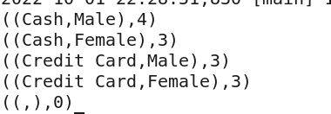

**Q)Find highest age and lowest age of customers according to city**

**CODE:**

DEFINE highlowage() RETURNS C{

log=load '/user/training/Pallavi/cust' using PigStorage(',') AS (id:int,name:chararray,age:int,gender:chararray,city:chararray,pay:chararray);

gr=group log by city;

$C=foreach gr generate group,(MAX(log.$2),MIN(log.$2));

};

**TERMINAL:**

pig -f /home/training/Desktop/highlowage.pig

pig

import '/home/training/Desktop/highlowage.pig';

Aa =highlowage();

Dump aa;

**OUTPUT:**

